Q. Create the following network in simulation
- Create a network with a hub and 4 PCs
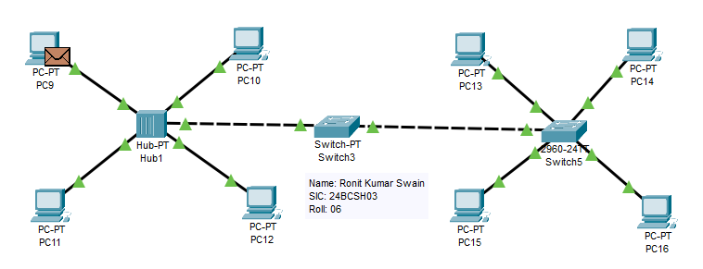

- Create a network with a switch and 4 PCs

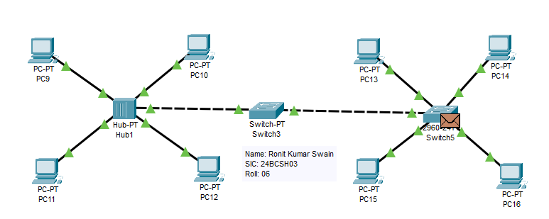

- Connect the switch and hub with another switch

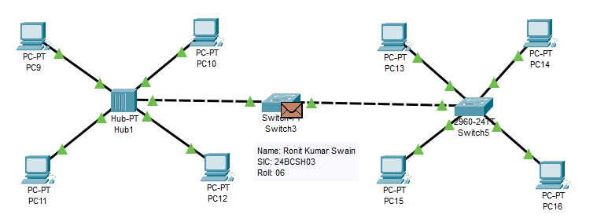

- Send PDUs and check the connectivity of the network.

